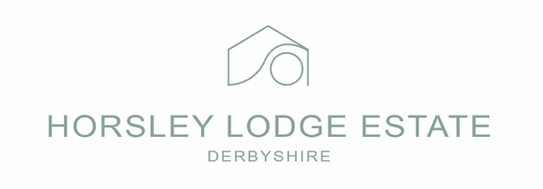
Privacy Policy
Horsley Lodge Estate

Horsley Lodge Estate are committed to protecting your privacy and ensuring that your personal data is handled safely and responsibly. This Privacy Policy explains how we collect, use, store, and protect your personal information when you interact with us.

What Personal Data We Collect
Guests & Customers:
- Name, address, email address, telephone number
- Booking details for hotel, restaurant, events and golf
- Payment information, processed securely via third-party providers
- Dietary requirements and allergies (with your consent)
- Vehicle registration numbers for parking management
- CCTV images for safety and security
Events & Weddings:
- Guest lists
- Special requirements and preferences
- Supplier and contractor details
Employees & Contractors
- Contact Details
- Employment Records
- Right to work documentation
- Training records

How We Collect Your Data
We collect personal data when you:
- Make a booking or enquiry
- Stay with us or attend an event
- Contact us by phone, email, or in person
- Use our website
- Apply for a job or work as a contractor

How We Use Your Personal Data
We use your data to:
- Manage bookings, reservations, and events
- Provide accommodation, food, drink, and services
- Communicate with you regarding your visit
- Process payments and refunds
- Comply with legal and regulatory obligations
- Improve our services and customer experience
- Ensure safety and security on our premises

Lawful Basis for Processing
We process your personal data under the following lawful bases:
- Contractual necessity – to fulfil bookings and services
- Legal obligation – health, safety, tax, and employment law
- Legitimate interests – service improvement, security, fraud prevention
- Consent – marketing communications and dietary/allergen information
You may withdraw consent at anytime

Special Category Data
Where necessary, we may collect special category data such as:
- Dietary and allergen information
- Health or accessibility requirements
This data is processed only with your explicit consent and is handled with enhanced security.

Sharing Your Data
We only share personal data where necessary, including with:
- Payment processors
- Booking and property management systems
- Event suppliers (where relevant)
- IT and security service providers
- Legal or regulatory authorities (where required)
We do not sell your personal data.

Data Retention
We retain personal data only for as long as necessary:
- Booking and transaction records for 6 years
- CCTV footage for 30 days (unless required for investigation)
- Marketing data: until consent is withdrawn
- Employment records: in line with legal requirements

Your Data Protection Rights
You have the right to:
- Access your personal data
- Request correction of inaccurate data
- Request deletion of your data
- Restrict or object to processing
- Data portability
- Withdraw consent at any time
To exercise your rights, contact us on 01332 780838 or email: reception@horsleylodgeestate.co.uk

CCTV
CCTV is used across Horsley Lodge Estate for:
- Crime prevention
- Safety of guests, staff and property
Footage is monitored responsibly and accessed only by authorised personel.

Data Security
We take appropriate technical and organisational measures to protect personal data, including:
- Secure IT systems
- Restricted access to sensitive information
- Staff training on data protection
- Secure disposal of data

Cookies & Website Use
Our website may use cookies to improve user experience. You can manage cookie preferences via your browser settings.

Complaints
If you have concerns about how your data is handled, please contact us first.
You also have the right to complain to the Information Commissioner’s Office (ICO):
WWW.ICO.ORG.UK
This Privacy Policy is reviewed regularly and updated as required.

